DAY 2 – XRAY SETUP & CONFIGURATION

1. Xray Setup
1.1 Xray Cloud – Overview
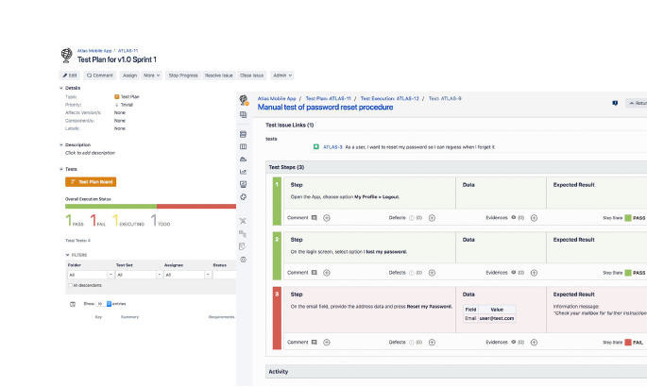
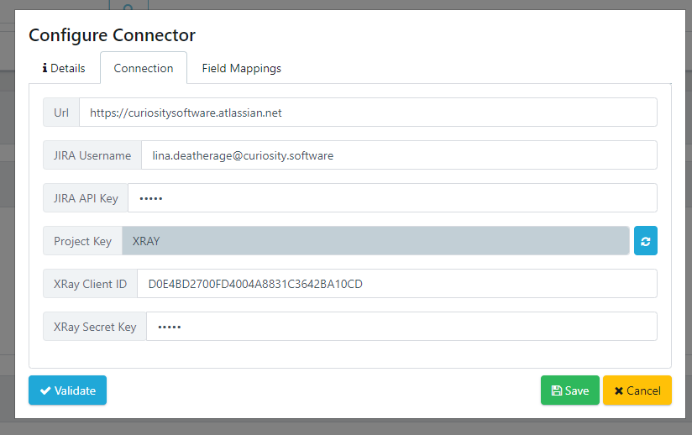
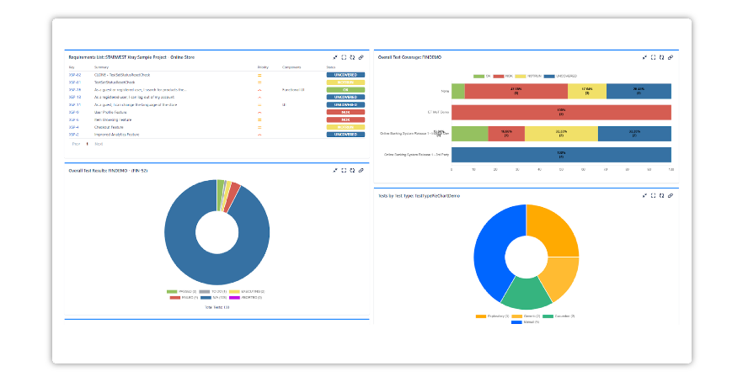

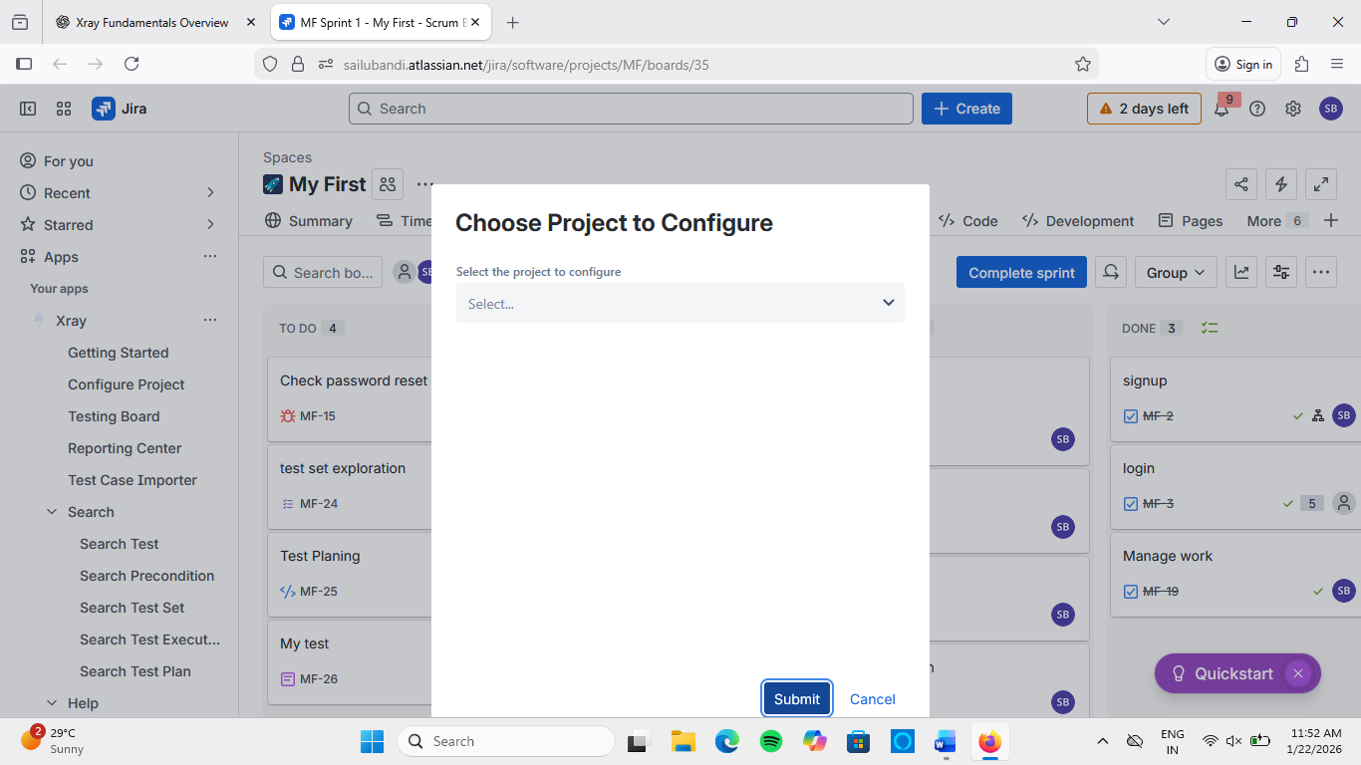

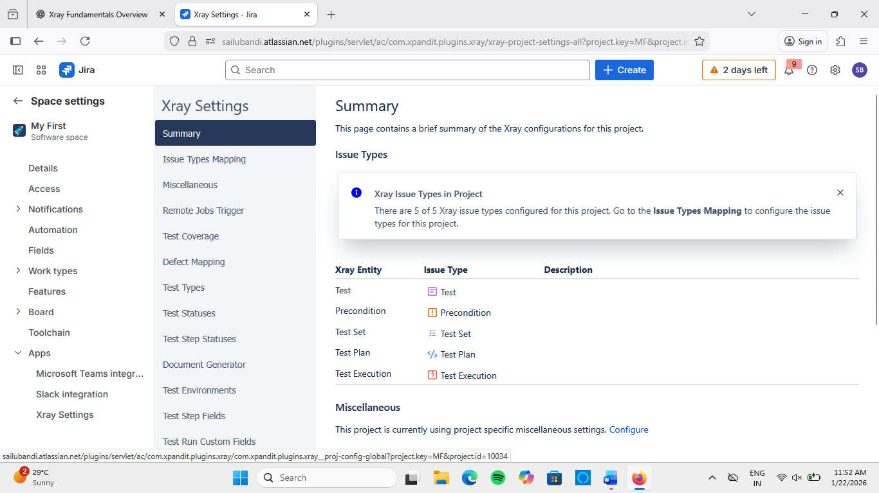
Xray Cloud is a SaaS-based test management solution that runs inside Jira Cloud.
Key Characteristics:
- No server installation required
- Managed and updated automatically
- Integrated directly with Jira issues
- Suitable for Agile, DevOps, and CI/CD pipelines
Why Organizations Choose Xray Cloud:
- Faster setup
- Lower maintenance
- Easy scalability
- Secure cloud hosting by Atlassian

1.2 Project-Level Configuration
Each Jira project can have custom Xray configurations.
Project-Level Settings Include:
- Enabling Xray issue types
- Test coverage rules
- Workflow mapping
- Test repository visibility
📌 Use Case:
Different projects (Web App vs Mobile App) may follow different testing strategies.

1.3 Global vs Project Settings
Setting Type | Global Settings | Project Settings
Scope | Entire Jira instance | Single Jira project
Managed By | Jira/Xray Admin | Project Admin
Examples | Issue types, permissions | Test workflows, coverage
Impact | All teams | One team/project
👉 Best Practice:
Keep standards globally, customize behavior per project.

2. Xray Issue Types & Structure

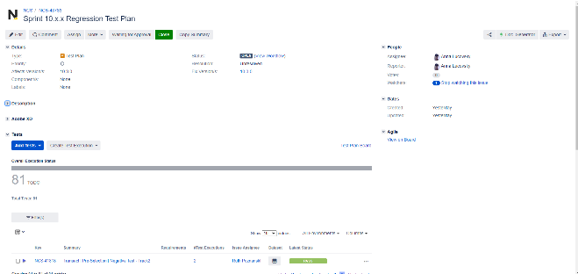
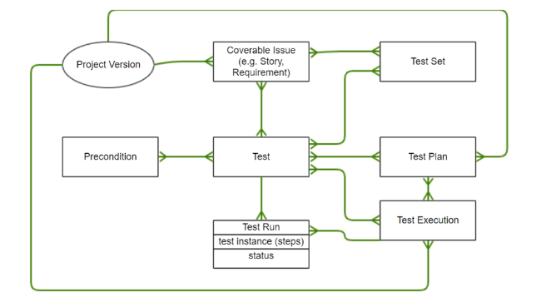
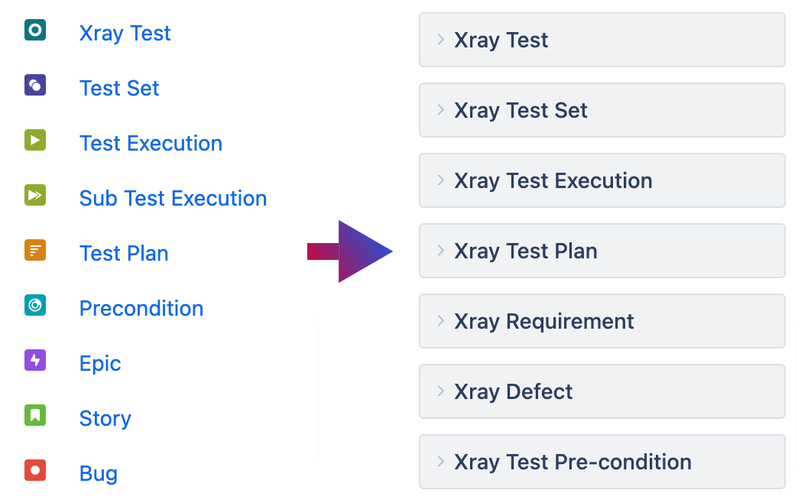

2.1 Test Issue – Structure
A Test represents a test case.
Main Fields:
- Summary
- Test Type (Manual / Cucumber / Automation)
- Test Steps
- Expected Results
- Preconditions
- Linked Requirements (Stories)
📌 Hands-on
- Go to Create Issue
- Select Issue Type → Test
- Add steps and expected results
- Save and review test details
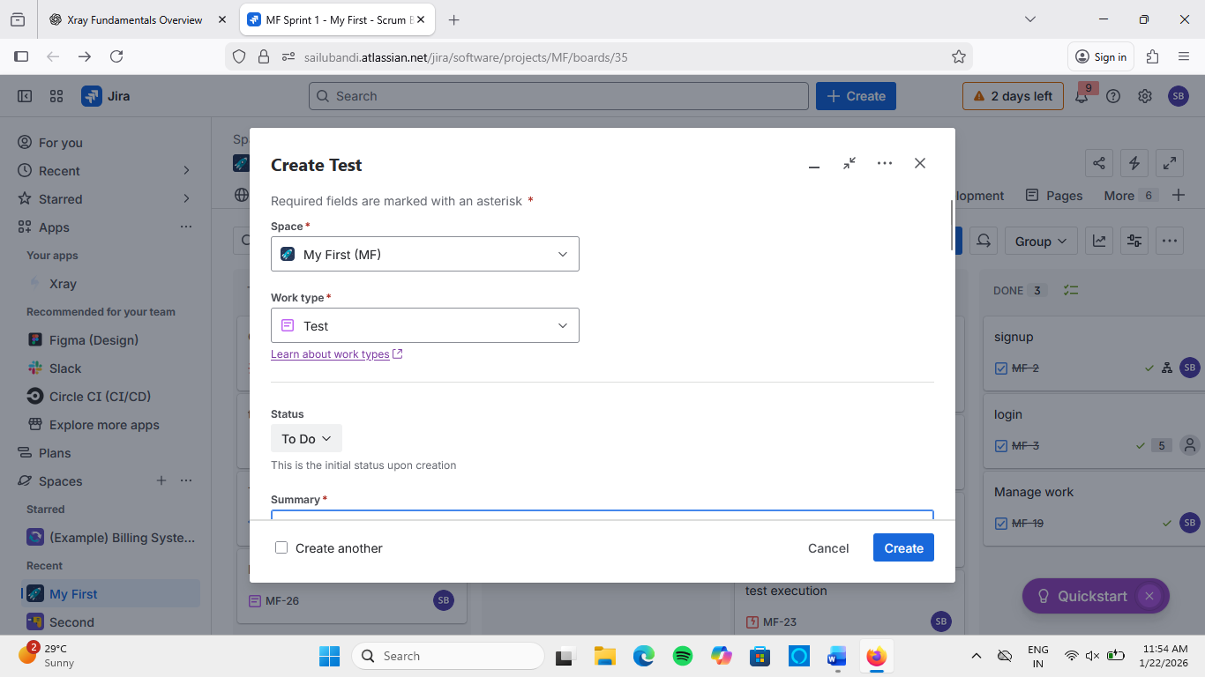

2.2 Test Execution – Structure
A Test Execution records actual execution results.
Contains:
- List of executed Tests
- Execution status (Pass/Fail)
- Tester name
- Execution date
- Evidence (screenshots, logs)
📌 Hands-on
- Create Issue → Test Execution
- Add existing Tests
- Execute tests and update status
- Attach evidence
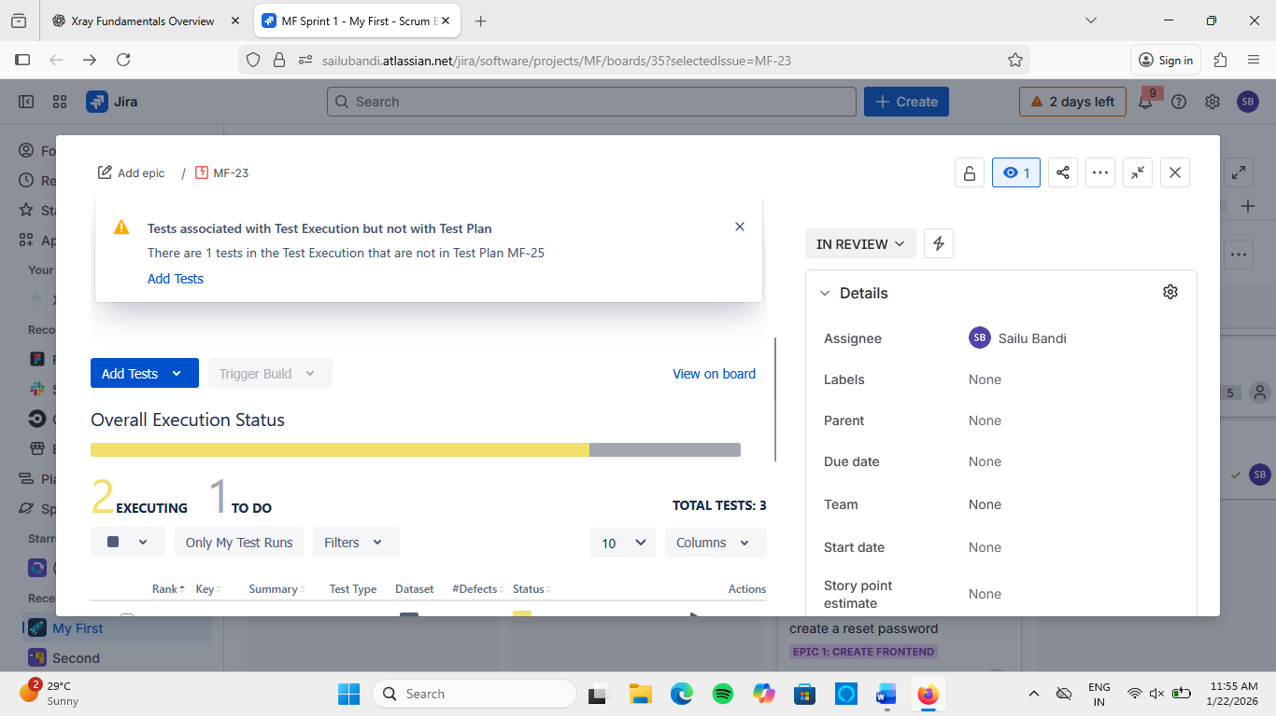

2.3 Test Plan vs Test Set
Aspect | Test Plan | Test Set
Purpose | Release / Sprint planning | Logical grouping
Usage | High-level planning | Regression / Module testing
Timeline | Long-term | Short-term
Scope | Release-wide | Feature-based
📌 Hands-on
- Create a Test Plan for Sprint 1
- Add Tests
- Create a Test Set for Login module
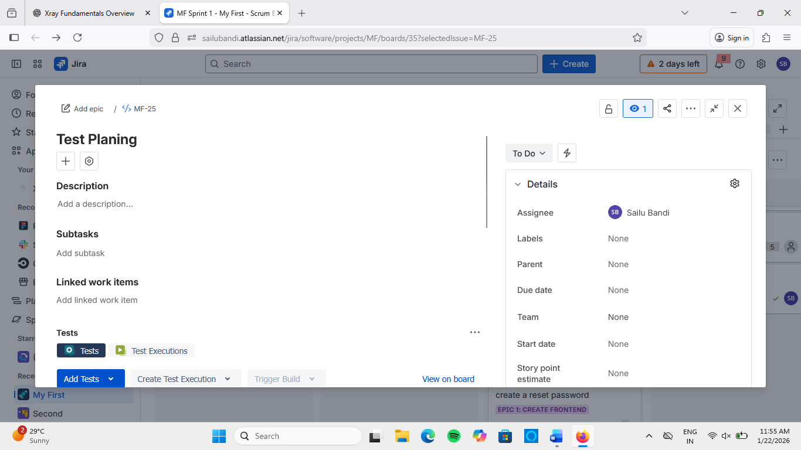

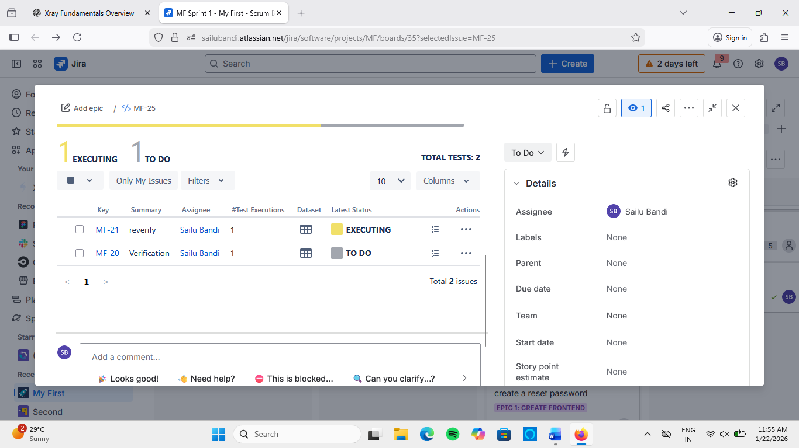

2.4 Precondition Reuse
Preconditions define requirements before testing.
Examples:
- User must be logged in
- Database must be connected
📌 Advantages
- Avoid repetition
- Easy maintenance
- Reusable across tests
📌 Hands-on
- Create Issue → Precondition
- Define condition
- Link it to multiple Tests

3. UI & Xray Panels
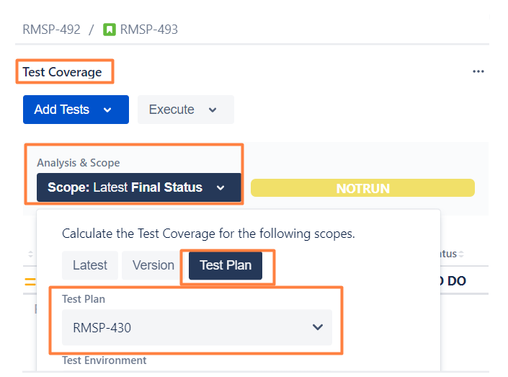
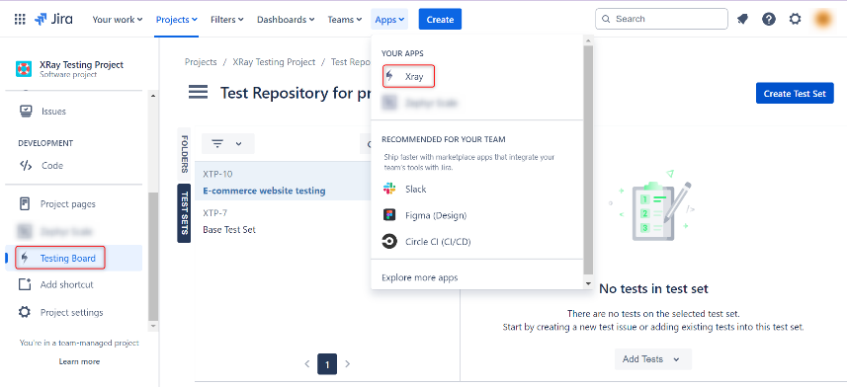
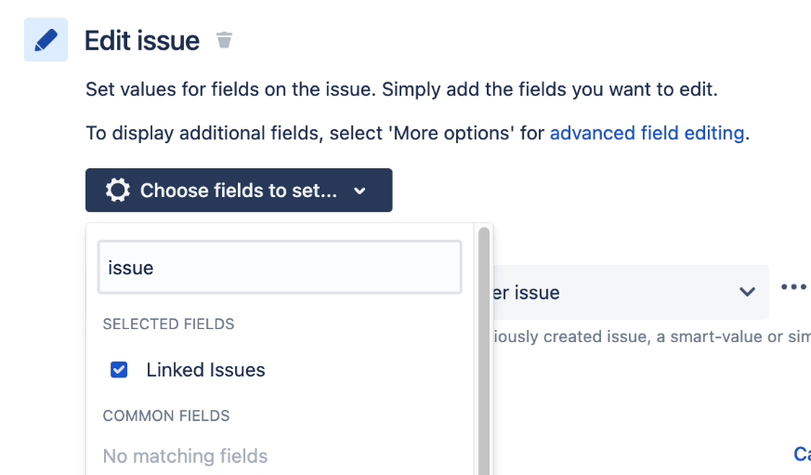

3.1 Xray Panels
Xray adds custom panels inside Jira issues.
Common Panels:
- Test Coverage Panel
- Test Execution Panel
- Defect Panel
These panels provide real-time testing visibility.

3.2 Coverage View
Shows:
- Which Tests cover which Stories
- Coverage percentage
- Untested requirements
📌 Hands-on
- Open a Story
- Scroll to Xray Coverage Panel
- Link Tests
- Observe coverage status
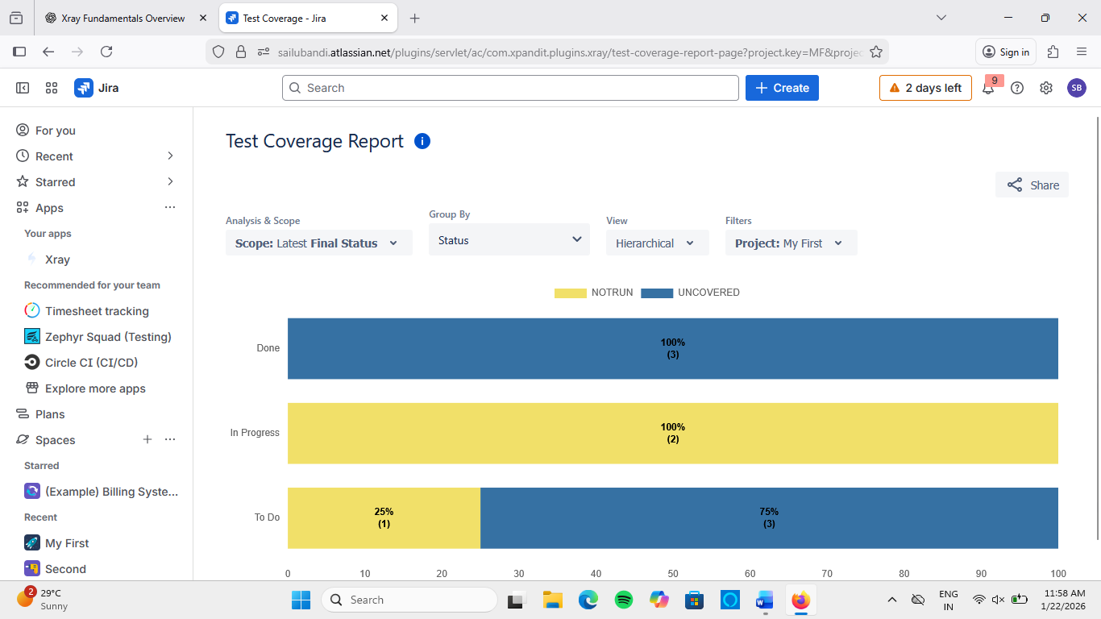

3.3 Execution View
Displays:
- Execution status
- Failed tests
- Execution history
📌 Hands-on
- Open Test Execution
- Execute tests
- Monitor real-time status updates
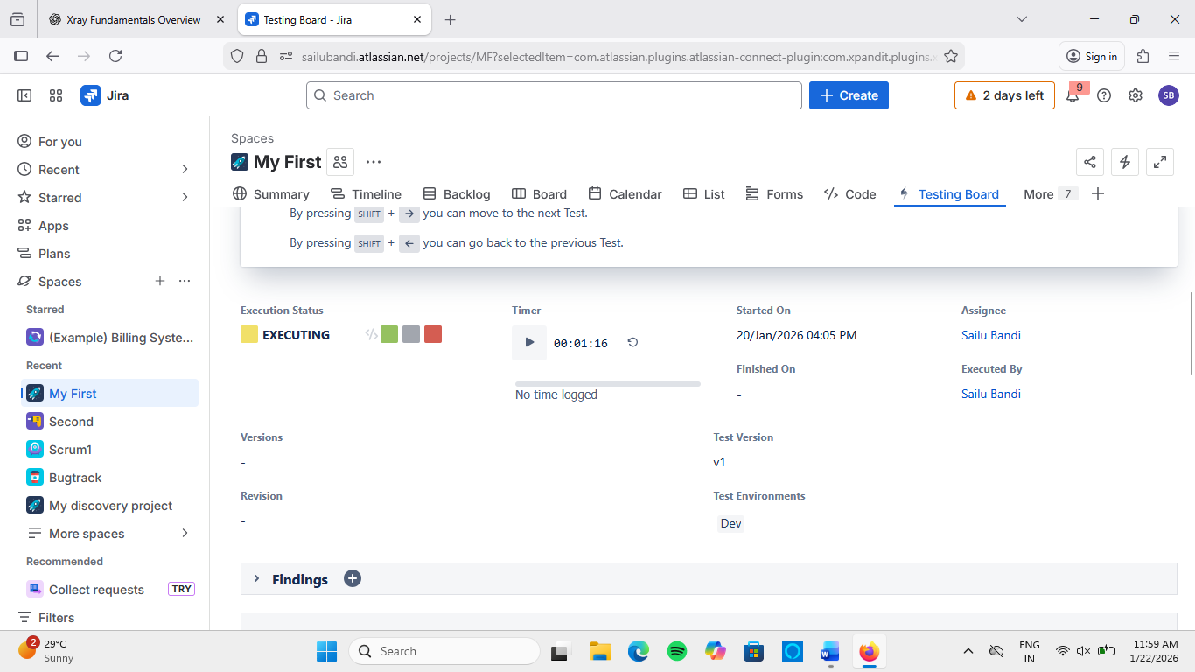

3.4 Defect Visibility
Xray allows linking Bugs to:
- Tests
- Test Executions
📌 Benefit
- Clear traceability between failure and defect
- Faster debugging

3.5 Navigation Shortcuts
Useful shortcuts:
- Test Repository
- Bulk Test Execution
- Requirement Traceability
📌 Improves tester productivity significantly.

4. Roles & Permissions
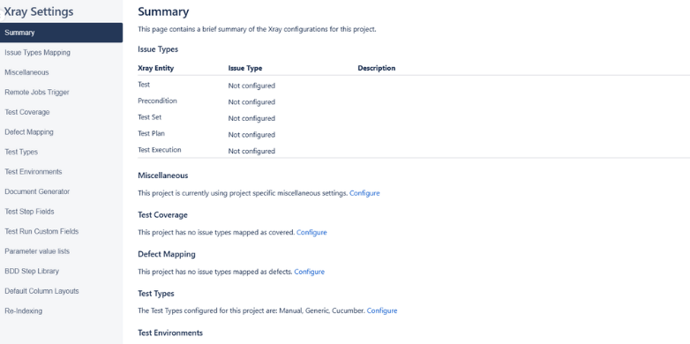
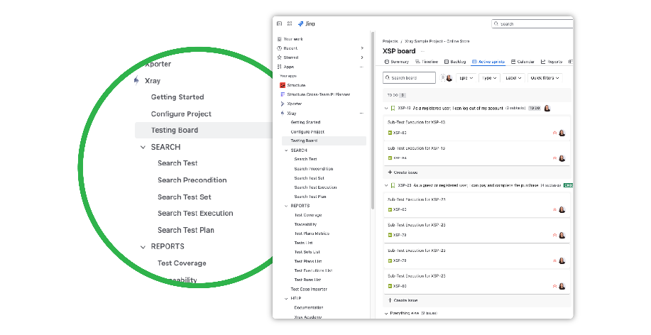
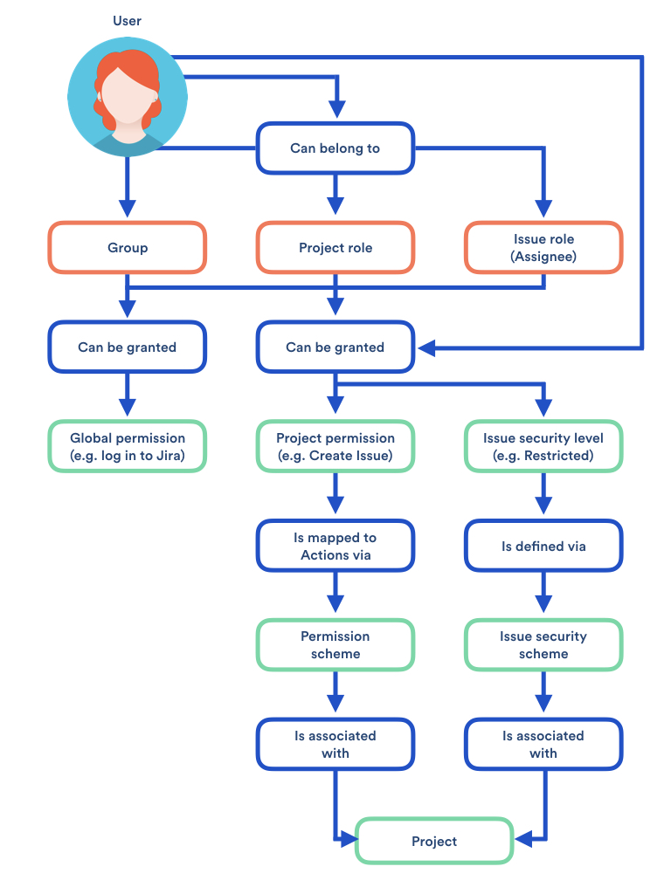

4.1 QA Role
Permissions:
- Create Tests & Executions
- Execute Tests
- Attach evidence
- View reports

4.2 Developer Role
Permissions:
- View Tests
- View execution results
- Link bugs
- Cannot modify execution results (usually)

4.3 Admin Role
Permissions:
- Manage workflows
- Configure Xray settings
- Assign permissions
- License management

4.4 Common Permission Issues
Issue | Reason
Cannot execute test | Missing transition permission
Cannot edit test | Edit issue permission missing
Cannot see Xray panels | Xray access not enabled
📌 Solution:
Verify Project Permission Scheme and Xray Access Rights.

5. Hands-on Practice (Mandatory Lab)
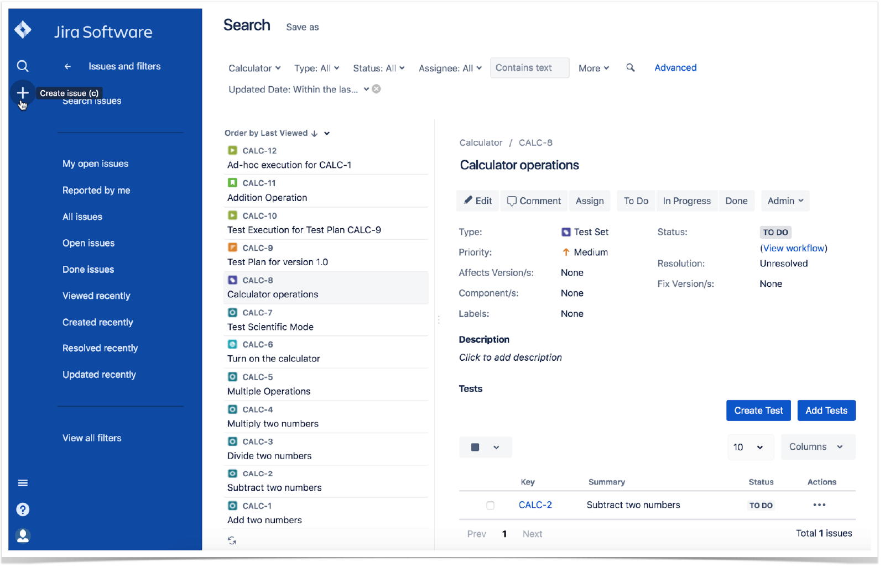
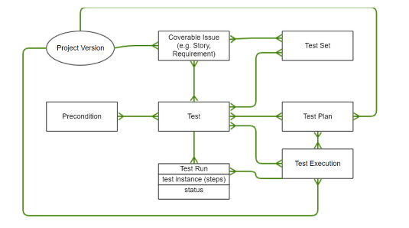
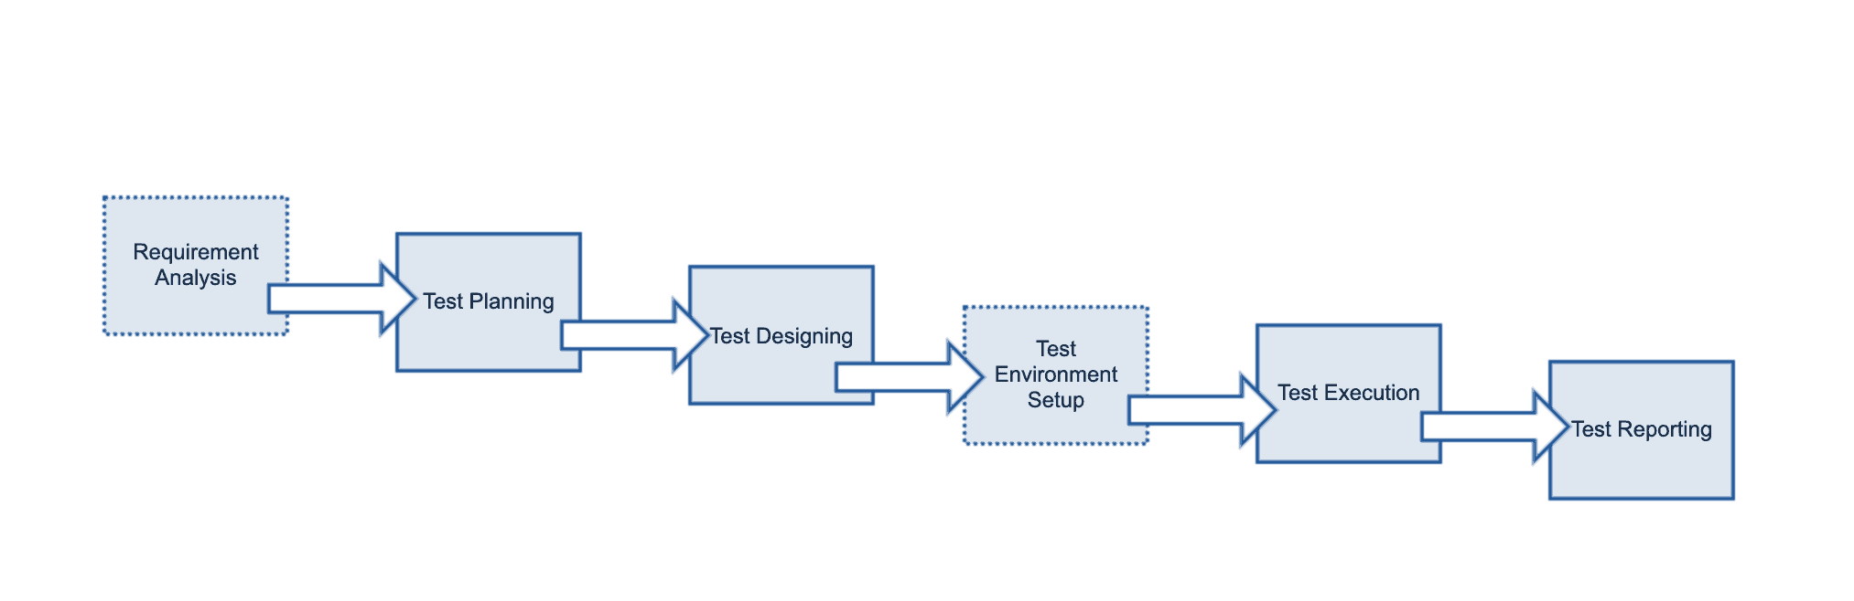
Hands-on Tasks
✅ Create:
- 1 Test
- 1 Precondition
- 1 Test Set
- 1 Test Plan
- 1 Test Execution
✅ Perform:
- Execute tests
- Update results
- Attach evidence
- Link defect
✅ Validate:
- Edit permissions
- Execution rights
- Coverage visibility

6. Summary
Day 2 focused on setting up and configuring Xray, understanding issue structures, navigating UI panels, managing roles and permissions, and performing real hands-on testing activities.

